**BANK LOAN REPORT QUERY DOCUMENT**

1. **BANK LOAN REPORT | SUMMARY**

**KPI’s:**

**1.Total Loan Applications**

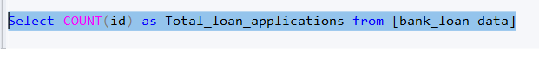

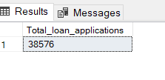

**2. MTD Loan Applications**

SELECT COUNT(id) AS Total_Applications FROM [bank_loan data]

where MONTH (issue_date) = 12

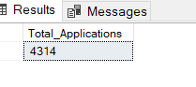

**3. PMTD Loan Applications**

SELECT COUNT(id) AS Previousmonth_Total_Applications FROM [bank_loan data]

where MONTH (issue_date) = 11

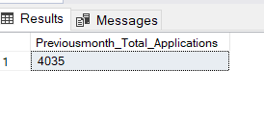

**4.Total Funded Amount**

SELECT SUM(loan_amount) AS Total_Funded_Amount FROM [bank_loan data]

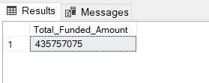

**5.** **MTD Total Funded Amount**

SELECT SUM(loan_amount) AS MonthTotal_Funded_Amount FROM [bank_loan data]

where MONTH(issue_date)=12

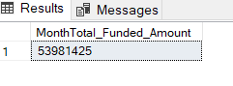

**6.** **PMTD Total Funded Amount**

SELECT SUM(loan_amount) AS PMonthTotal_Funded_Amount FROM [bank_loan data]

where MONTH(issue_date)=11

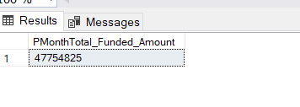

**7. Total Amount Received**

Select SUM(total_payment) as total_amt_rec from [bank_loan data]

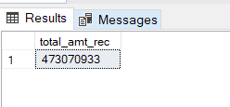

**8. MTD Total Amount Received**

Select SUM(total_payment) as Mtotal_amt_rec from [bank_loan data]

where MONTH (issue_date) = 12

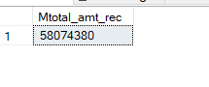

**9.PMTD Total Amount Received**

Select SUM(total_payment) as PMtotal_amt_rec from [bank_loan data]

where MONTH (issue_date) = 11

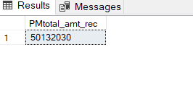

**10. Average Interest Rate**

Select ROUND(AVG(int_rate),4) *100 as average_intrate from [bank_loan data]

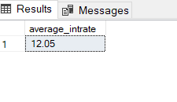

**11. MTD Average Interest Rate**

Select ROUND(AVG(int_rate),4) *100 as MTD_average_intrate from [bank_loan data]

where MONTH(issue_date)=12

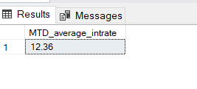

**12 PMTD Average Interest Rate**

Select ROUND(AVG(int_rate),4) *100 as PMTD_average_intrate from [bank_loan data]

where MONTH(issue_date)=11

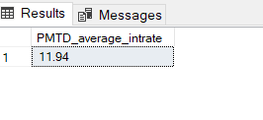

**13. Average DTI**

Select ROUND(AVG(dti),4) *100 as average_dti from [bank_loan data]

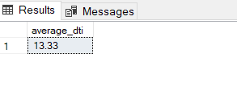

**14 Average MTD_DTI**

Select ROUND(AVG(dti),4) *100 as MTD_average_dti from [bank_loan data]

where MONTH(issue_date)=12

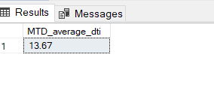

**15. Average PMTD_DTI**

Select ROUND(AVG(dti),4) *100 as PMTD_average_dti from [bank_loan data]

where MONTH(issue_date)=11

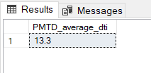

**GOOD LOAN ISSUED**

**1.Good Loan Percentage**

SELECT

round((COUNT(CASE WHEN loan_status = 'Fully Paid' OR loan_status = 'Current' THEN id END) * 100.0) /

COUNT(id),4) AS Good_Loan_Percentage

FROM [bank_loan data]

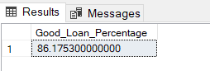

**2. Total Good loan Appln**

SELECT COUNT(id) AS Good_Loan_Applications FROM [bank_loan data]

WHERE loan_status = 'Fully Paid' OR loan_status = 'Current'

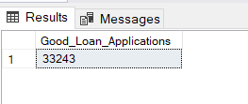

**3. Good Loan funded amt**

SELECT SUM(loan_amount) AS Good_Loan_Funded_amount FROM [bank_loan data]

WHERE loan_status = 'Fully Paid' OR loan_status = 'Current'

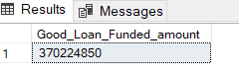

**4. Good loan amt received**

SELECT SUM(total_payment) AS Good_Loan_amount_received FROM [bank_loan data]

WHERE loan_status = 'Fully Paid' OR loan_status = 'Current'

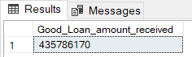

**BAD LOAN ISSUED**

**1.Bad Loan Percentage**

SELECT

round((COUNT(CASE WHEN loan_status = 'Charged Off' THEN id END) * 100.0) /

COUNT(id),4) AS Bad_Loan_Percentage

FROM [bank_loan data]

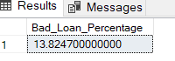

**2. Total Bad loan Appln**

SELECT COUNT(id) AS Bad_Loan_Applications FROM [bank_loan data]

WHERE loan_status = 'Charged Off'

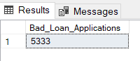

**3. Bad Loan funded amt**

SELECT SUM(loan_amount) AS Bad_Loan_Funded_amount FROM [bank_loan data]

WHERE loan_status = 'Charged Off'

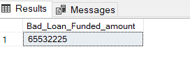

**4. Bad loan amt received**

SELECT SUM(total_payment) AS Bad_Loan_rec_amount FROM [bank_loan data]

WHERE loan_status = 'Charged Off'

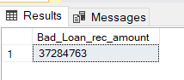

**LOAN STATUS**

SELECT

loan_status,

COUNT(id) AS LoanCount,

SUM(total_payment) AS Total_Amount_Received,

SUM(loan_amount) AS Total_Funded_Amount,

AVG(int_rate * 100) AS Interest_Rate,

AVG(dti * 100) AS DTI

FROM

[bank_loan data]

GROUP BY

loan_status

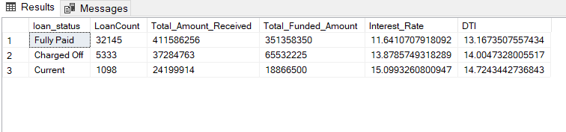

**MTD Loan status**

SELECT

loan_status,

COUNT(id) AS LoanCount,

SUM(total_payment) AS MTD_Total_Amount_Received,

SUM(loan_amount) AS MTD_Total_Funded_Amount

FROM

[bank_loan data]

Where MONTH (issue_date)=12

GROUP BY

loan_status

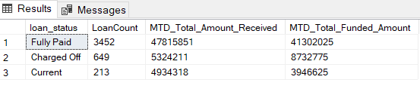

1. **BANK LOAN REPORT | OVERVIEW**

**MONTH**

SELECT

MONTH(issue_date) as Month_Number,

DATENAME(month,issue_date) as Month_name,

COUNT(id) AS Total_Loan_Applications,

SUM(loan_amount) AS Total_Funded_Amount,

SUM(total_payment) AS Total_Amount_Received

from [bank_loan data]

Group by MONTH(issue_date),DATENAME(month,issue_date)

Order by Month(issue_date) ASC

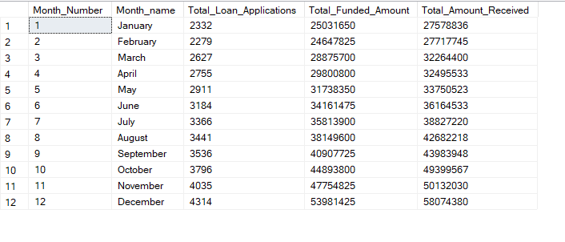

**STATE**

SELECT

address_state,

COUNT(id) AS Total_Loan_Applications,

SUM(loan_amount) AS Total_Funded_Amount,

SUM(total_payment) AS Total_Amount_Received

from [bank_loan data]

Group by address_state

order by COUNT(id) ASC

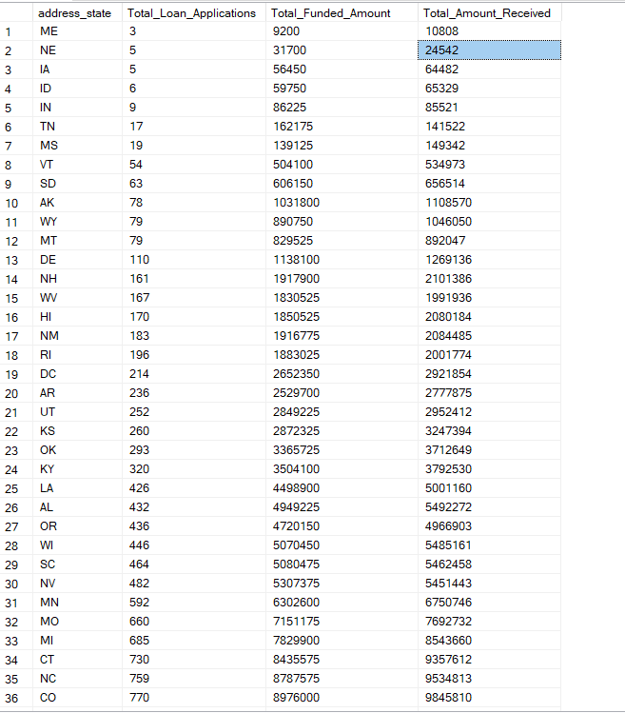 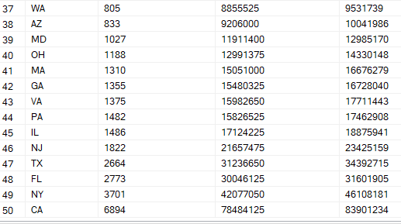

**TERM**

Select term ,

COUNT(id) AS Total_Loan_Applications,

SUM(loan_amount) AS Total_Funded_Amount,

SUM(total_payment) AS Total_Amount_Received

from [bank_loan data]

Group by term

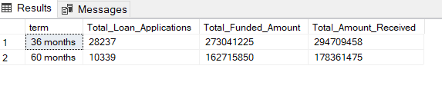

**EMPLOYEE LENGTH**

Select emp_length ,

COUNT(id) AS Total_Loan_Applications,

SUM(loan_amount) AS Total_Funded_Amount,

SUM(total_payment) AS Total_Amount_Received

from [bank_loan data]

Group by emp_length

Order by emp_length

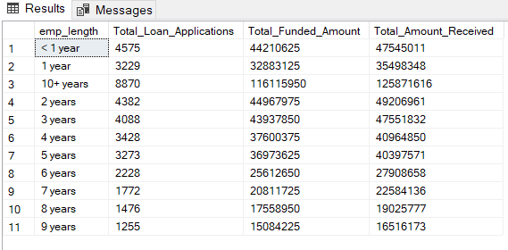

**PURPOSE**

Select purpose,

COUNT(id) AS Total_Loan_Applications,

SUM(loan_amount) AS Total_Funded_Amount,

SUM(total_payment) AS Total_Amount_Received

from [bank_loan data]

Group by purpose

Order by COUNT(id)

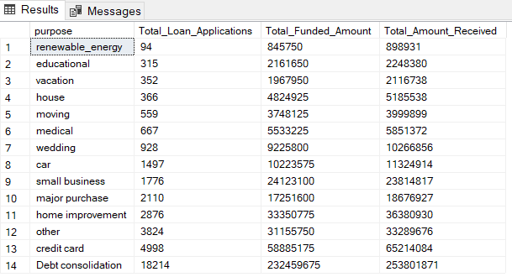

**HOME OWNERSHIP**

Select home_ownership,

COUNT(id) AS Total_Loan_Applications,

SUM(loan_amount) AS Total_Funded_Amount,

SUM(total_payment) AS Total_Amount_Received

from [bank_loan data]

Group by home_ownership

Order by COUNT(id)

